
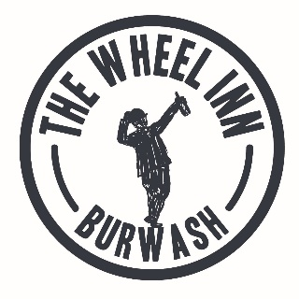

We love our local suppliers and are always working hard to find the best out there. If you would like to know about any of them just ask…
Head Chef – Nicu Cristian
Pub Menu
NIBBLES
Olives & sundried tomatoes £4.00
Charcuterie platter £6.50
Breads, butter & oil £3.50
STARTERS
Chefs dirty fries £6.00
Scotch egg with homemade chutney £6.00
Baked Camembert, toasted baguette, chutney £6.00
Whitebait, homemade tartare sauce £5.00
Mussels popcorn, curried aioli, lime, salad £5.50
Terrine of the day, piccalilli, toasted bread £5.50
Vegetable quiche of the day, seasonal salad £5.50

MAIN COURSES
Garden pea puree and goats cheese risotto £12.00
Harveys battered fish & chips, mushy peas, tartare sauce £12.50
Lamb skewers served with vegetable couscous and minted yoghurt £12.50
Chefs steak, garlic mushrooms, roasted tomato and a choice of peppercorn or blue cheese sauce £18.50
Chicken Caesar salad, with croutons and anchovies £12.50
Beef burger served with a choice of chunky or skinny chips and homemade onion rings £13.00
Haloumi Burger with tomato chutney, a choice of chunky or skinny chips, and homemade onion rings £12.50
Pie of the day served with mash puree and seasonal vegetables £12.00

PIZZAS
Margherita pizza, homemade tomato sauce, mozzarella, basil £9.50
Meat feast, homemade tomato sauce, mozzarella, pepperoni, chorizo and bacon £11.50
Spicy pizza, homemade tomato sauce, mozzarella, chilli and nduja chorizo £11.50
Vegetarian pizza, homemade tomato sauce, mozzarella, mushrooms, onion, piquillo peppers £10.50
Under the sea, homemade tomato sauce, mozzarella, mussels, squid, prawns £12.00
SIDES £3.00
Onion rings
Coleslaw
Corn on the cob
House salad
Seasonal vegetables
Chunky or skinny chips

SANDWICHES (All sandwiches are served with chips and salad, 12-3 daily)
Freshly made fish finger open sandwich, homemade tartare sauce, mushy peas, lemon £7.50
Rarebit toasted sandwich £7.00
Steak sandwich with horseradish sauce £8.50
Grilled halloumi and sundried tomato £7.00
Wheel club sandwich £8.00
Brie and Cranberry sauce £7.25
DESSERTS
Chocolate flourless cake, raspberry sorbet £5.50
Seasonal cheesecake, fruit compote £5.50
Summer pudding, clotted cream £5.50
3 cheese board, frozen grapes £7.50
3 scoops of ice cream £4.50
Brioche bread and butter pudding with custard £5.50

